|  |
| --- |
| Gamindustri |
| Sky Blast |
|  |
| Version 5.4.1f1  All work Copyright © 2016 by Gamindustri.  All rights reserved. |
| **Ronnel Ian Villarino** |
|  |

|  |
| --- |
| October 3, 2016 |

# Table of Contents

Contents

Table of Contents 2

Contents 2

Version History 3

**Details** 4

# Version History

Version 5.4.1f1 – Current version. No real changes to game.

**Details**

1. **Game Overview**

The goal of the game is to fly through the good clouds (white with a blue outline) to get points while avoiding three bad clouds (black with a red outline).

1. **Game Play Mechanics**

The game play mechanics is simply dodging the bad clouds while trying to fly over the good clouds to earn points. They will fly for as long as they can.

1. **Camera**

Top-to-bottom view or can be considered bird’s eye view.

1. **Controls**

The game uses the mouse as a way to move the space ship.

1. **Saving and Loading**

There is no saving or loading in this game.

1. **Interface Sketch**

**This is the main interface when playing the game. The button is combined to represent both scenes; Main and Game.**

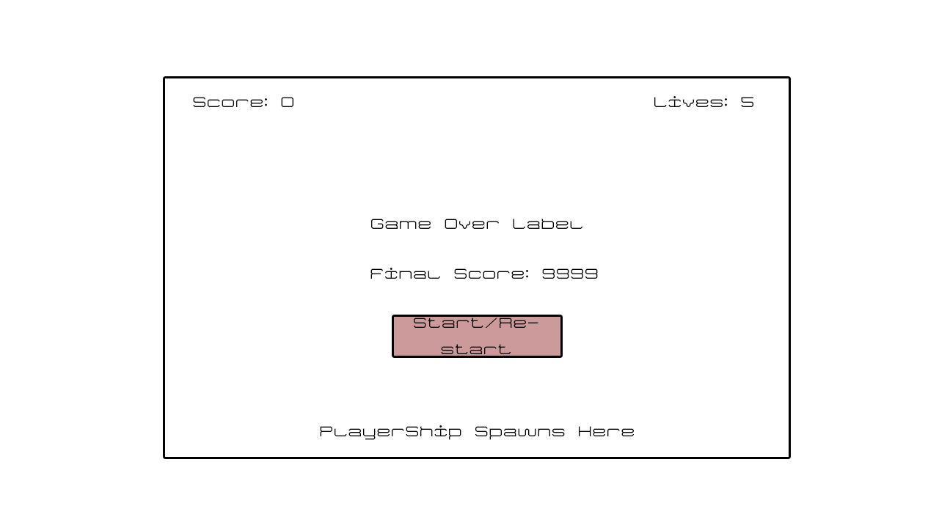

1. **Menu and Screen Descriptions**

**This is when the player starts the game. They are greeted with a button and the title.**

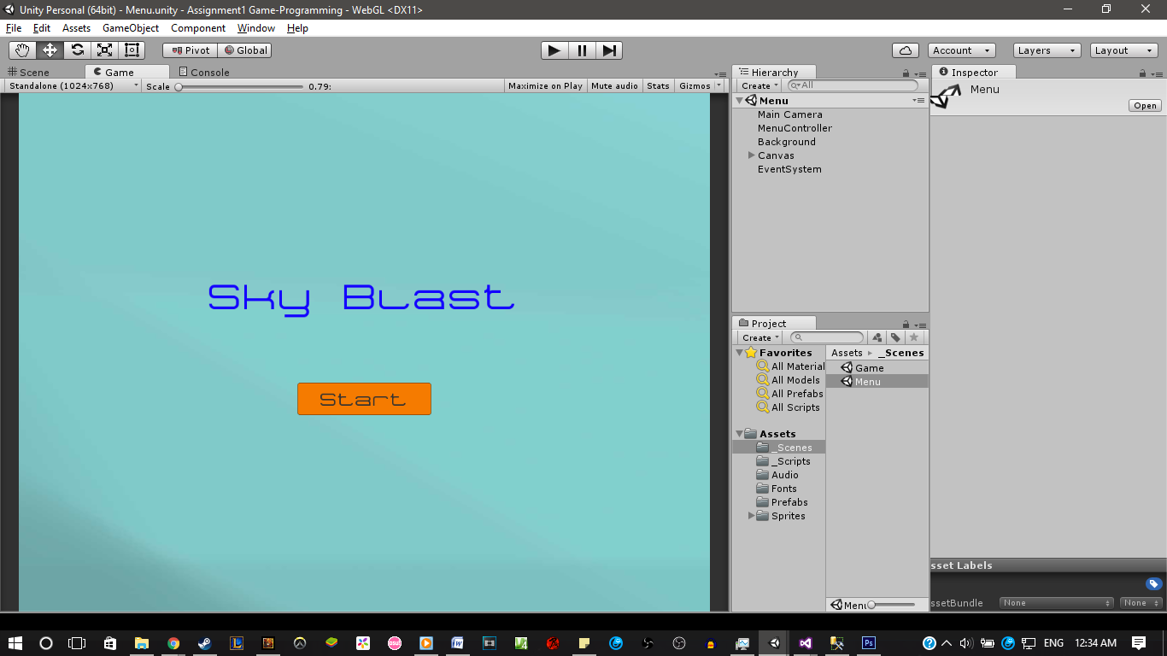

**This is when the player presses the button from the last screen. The game over, final score text, and the restart button appear when the player loses the game by letting his life go down to 0.**

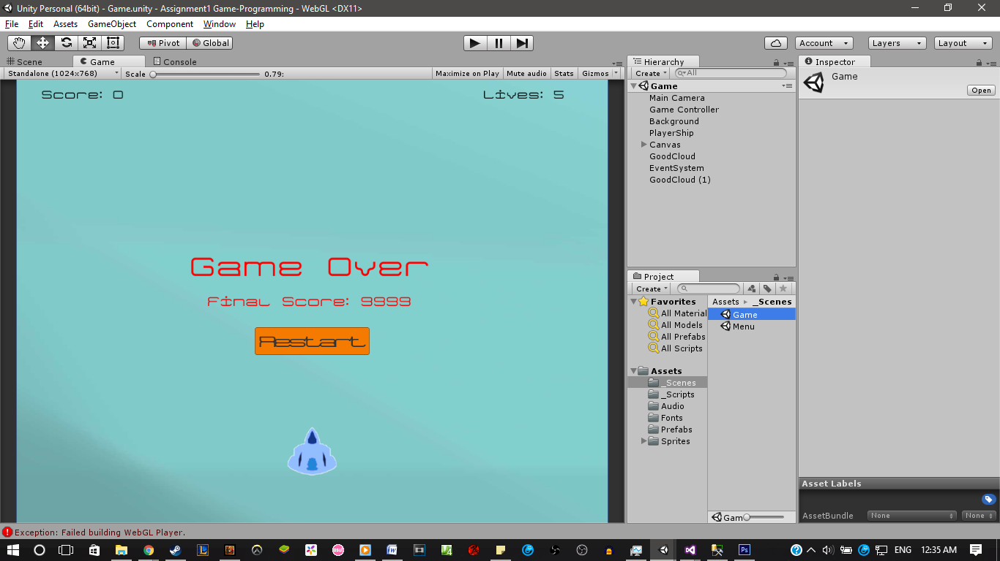

1. **Game World**

The game world is only a single level. This level is only about flying through the sky, dodging bad clouds while passing through the good clouds.

1. **Levels**

There is only one level as of now. This level is only flying through the sky.

1. **Game Progression**

There is no real game progression at this point of time. There may be a game progression in the future when it is updated.

1. **Characters**

The only character that the player uses is called the “playerShip”. It is a light-blue space ship with a white outline.

1. **Enemies**

The only enemy is a bad cloud. The bad cloud is coloured dark grey with red outline.

1. **Script**

There are several scripts in the game. There is each a script for the clouds which is identical to each other. Another one is for the player ship. The fourth script is for the background for when it scrolls. There is a game controller script for how the game is going to go. And the last script is for the menu when it switches scenes.

1. **Scoring**

The scoring is based on how many good clouds the player passes through. A good cloud offers 100 points every time the player passes through it.

1. **Sound Index**

There are four main sound effects with one substitution which is used for testing.

1. The first one is called “gameover” which is actually called ‘Yiruma – River Flows In You.’ This is used to play when the player reaches the game over screen. I chose this because it is to provide a sad feeling for not being able to reach far.
2. The second sound effect is called is ‘thunder’’ which is played when the player hits the ‘badCloud’.
3. The third is called “Vertigo” which is the main sound effect that plays when the player plays. This can also be considered the main background music for the game.
4. The last main sound effect is called “Woo” which I have taken from youtube. It is mainly played when the player passes through a good cloud. It can give a ‘good vibe’ despite it being loud and quite long.
5. The substitute is called “flight” which was used for the playerShip. This was used to test to see if the sounds are working properly.
6. **Art / Multimedia Index**

**This is the GoodCloud, which is used for the player to gain points**

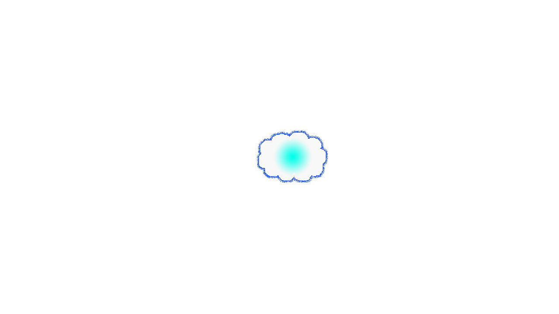

**This is the sprite for the badCloud, which reduces the player’s lives by 1 every time they are hit.**

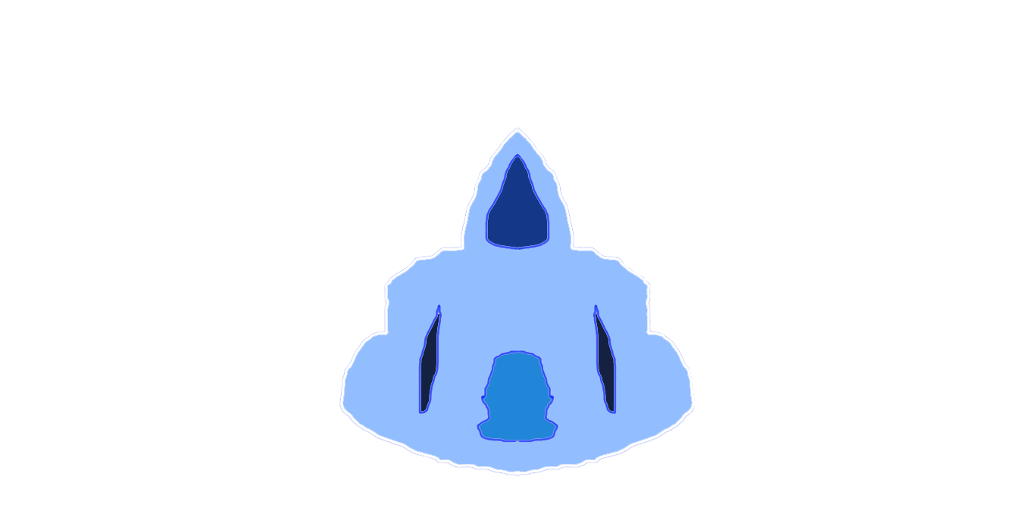

**This is the playerShip, which the player uses to play the game.**

1. **Future Features**



Some future features that may be implemented are

* An enemy ship that were able to shoot lasers at the player
* A boss that can be like a “bullet-hell” boss
* Boss level would be only you and the boss, no clouds of any kind